**DATA STRUCTURES DAY-4**

**1.**  C program for tree traversal.

#include <stdio.h>

#include <stdlib.h>

struct node {

int data;

struct node *leftChild;

struct node *rightChild;

};

struct node *root = NULL;

void insert(int data) {

struct node *tempNode = (struct node*) malloc(sizeof(struct node));

struct node *current;

struct node *parent;

tempNode->data = data;

tempNode->leftChild = NULL;

tempNode->rightChild = NULL;

//if tree is empty

if(root == NULL) {

root = tempNode;

} else {

current = root;

parent = NULL;

while(1) {

parent = current;

//go to left of the tree

if(data < parent->data) {

current = current->leftChild;

//insert to the left

if(current == NULL) {

parent->leftChild = tempNode;

return;

}

} //go to right of the tree

else {

current = current->rightChild;

//insert to the right

if(current == NULL) {

parent->rightChild = tempNode;

return;

}

}

}

}

}

struct node* search(int data) {

struct node *current = root;

printf("Visiting elements: ");

while(current->data != data) {

if(current != NULL)

printf("%d ",current->data);

//go to left tree

if(current->data > data) {

current = current->leftChild;

}

//else go to right tree

else {

current = current->rightChild;

}

//not found

if(current == NULL) {

return NULL;

}

}

return current;

}

void pre_order_traversal(struct node* root) {

if(root != NULL) {

printf("%d ",root->data);

pre_order_traversal(root->leftChild);

pre_order_traversal(root->rightChild);

}

}

void inorder_traversal(struct node* root) {

if(root != NULL) {

inorder_traversal(root->leftChild);

printf("%d ",root->data);

inorder_traversal(root->rightChild);

}

}

void post_order_traversal(struct node* root) {

if(root != NULL) {

post_order_traversal(root->leftChild);

post_order_traversal(root->rightChild);

printf("%d ", root->data);

}

}

int main() {

int i;

int array[7] = { 25, 14, 19, 82, 56, 41, 13 };

for(i = 0; i < 7; i++)

insert(array[i]);

i = 31;

struct node * temp = search(i);

if(temp != NULL) {

printf("[%d] Element found.", temp->data);

printf("\n");

}else {

printf("[ x ] Element not found (%d).\n", i);

}

i = 15;

temp = search(i);

if(temp != NULL) {

printf("[%d] Element found.", temp->data);

printf("\n");

}else {

printf("[ x ] Element not found (%d).\n", i);

}

printf("\nPreorder traversal: ");

pre_order_traversal(root);

printf("\nInorder traversal: ");

inorder_traversal(root);

printf("\nPost order traversal: ");

post_order_traversal(root);

return 0;

}

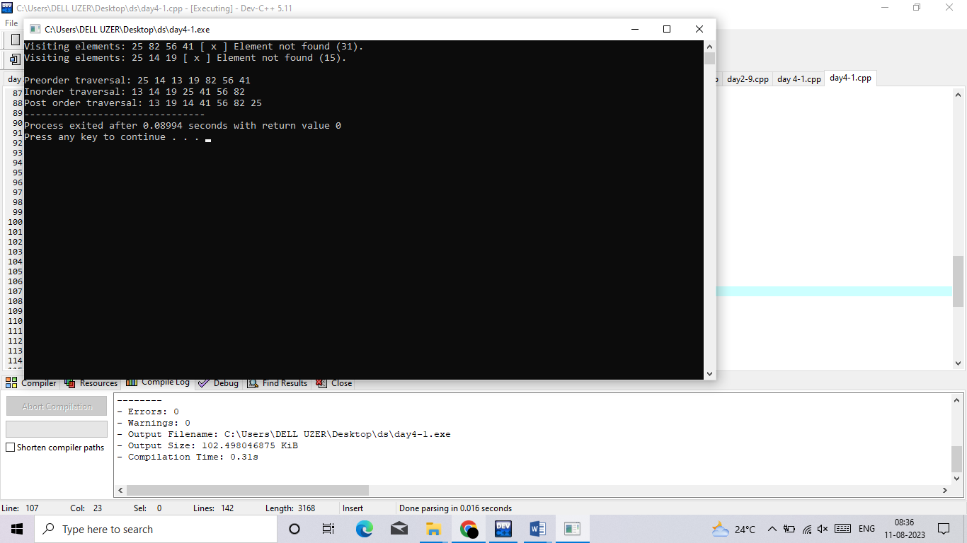

2. C program for implementing avl tree

#include <stdio.h>

#include <stdlib.h>

struct Node {

int key;

struct Node *left;

struct Node *right;

int height;

};

int max(int a, int b);

int height(struct Node *N) {

if (N == NULL)

return 0;

return N->height;

}

int max(int a, int b) {

return (a > b) ? a : b;

}

struct Node *newNode(int key) {

struct Node *node = (struct Node *)

malloc(sizeof(struct Node));

node->key = key;

node->left = NULL;

node->right = NULL;

node->height = 1;

return (node);

}

struct Node *rightRotate(struct Node *y) {

struct Node *x = y->left;

struct Node *T2 = x->right;

x->right = y;

y->left = T2;

y->height = max(height(y->left), height(y->right)) + 1;

x->height = max(height(x->left), height(x->right)) + 1;

return x;

}

struct Node *leftRotate(struct Node *x) {

struct Node *y = x->right;

struct Node *T2 = y->left;

y->left = x;

x->right = T2;

x->height = max(height(x->left), height(x->right)) + 1;

y->height = max(height(y->left), height(y->right)) + 1;

return y;

}

int getBalance(struct Node *N) {

if (N == NULL)

return 0;

return height(N->left) - height(N->right);

}

struct Node *insertNode(struct Node *node, int key) {

if (node == NULL)

return (newNode(key));

if (key < node->key)

node->left = insertNode(node->left, key);

else if (key > node->key)

node->right = insertNode(node->right, key);

else

return node;

node->height = 1 + max(height(node->left),

height(node->right));

int balance = getBalance(node);

if (balance > 1 && key < node->left->key)

return rightRotate(node);

if (balance < -1 && key > node->right->key)

return leftRotate(node);

if (balance > 1 && key > node->left->key) {

node->left = leftRotate(node->left);

return rightRotate(node);

}

if (balance < -1 && key < node->right->key) {

node->right = rightRotate(node->right);

return leftRotate(node);

}

return node;

}

struct Node *minValueNode(struct Node *node) {

struct Node *current = node;

while (current->left != NULL)

current = current->left;

return current;

}

struct Node *deleteNode(struct Node *root, int key) {

if (root == NULL)

return root;

if (key < root->key)

root->left = deleteNode(root->left, key);

else if (key > root->key)

root->right = deleteNode(root->right, key);

else {

if ((root->left == NULL) || (root->right == NULL)) {

struct Node *temp = root->left ? root->left : root->right;

if (temp == NULL) {

temp = root;

root = NULL;

} else

*root = *temp;

free(temp);

} else {

struct Node *temp = minValueNode(root->right);

root->key = temp->key;

root->right = deleteNode(root->right, temp->key);

}

}

if (root == NULL)

return root;

root->height = 1 + max(height(root->left),

height(root->right));

int balance = getBalance(root);

if (balance > 1 && getBalance(root->left) >= 0)

return rightRotate(root);

if (balance > 1 && getBalance(root->left) < 0) {

root->left = leftRotate(root->left);

return rightRotate(root);

}

if (balance < -1 && getBalance(root->right) <= 0)

return leftRotate(root);

if (balance < -1 && getBalance(root->right) > 0) {

root->right = rightRotate(root->right);

return leftRotate(root);

}

return root;

}

// Print the tree

void printPreOrder(struct Node *root) {

if (root != NULL) {

printf("%d ", root->key);

printPreOrder(root->left);

printPreOrder(root->right);

}

}

int main() {

struct Node *root = NULL;

root = insertNode(root, 2);

root = insertNode(root, 1);

root = insertNode(root, 7);

root = insertNode(root, 4);

root = insertNode(root, 5);

root = insertNode(root, 3);

root = insertNode(root, 8);

printPreOrder(root);

root = deleteNode(root, 3);

printf("\nAfter deletion: ");

printPreOrder(root);

return 0;

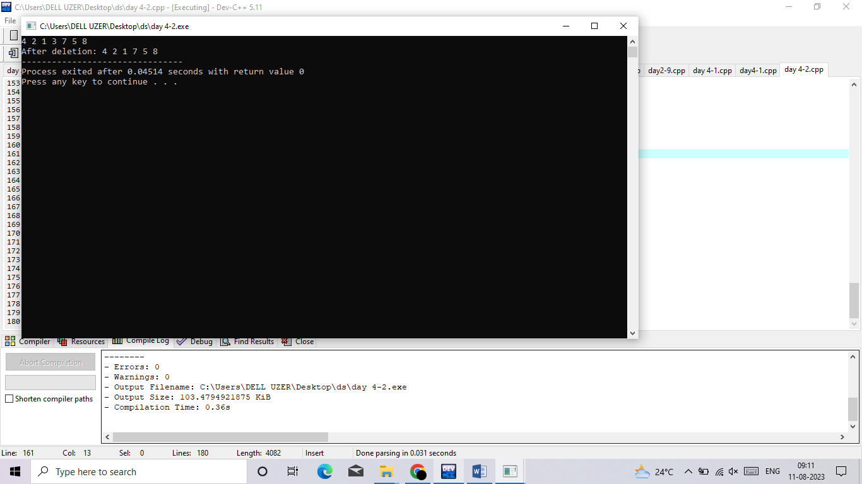}

3. C program to implement hashing using linear probing

#include <stdio.h>

#include<stdlib.h>

#define TABLE_SIZE 10

int h[TABLE_SIZE]={NULL};

void insert()

{

int key,index,i,flag=0,hkey;

printf("\nenter a value to insert into hash table\n");

scanf("%d",&key);

hkey=key%TABLE_SIZE;

for(i=0;i<TABLE_SIZE;i++)

{

index=(hkey+i)%TABLE_SIZE;

if(h[index] == NULL)

{

h[index]=key;

break;

}

}

if(i == TABLE_SIZE)

printf("\nelement cannot be inserted\n");

}

void search()

{

int key,index,i,flag=0,hkey;

printf("\nenter search element\n");

scanf("%d",&key);

hkey=key%TABLE_SIZE;

for(i=0;i<TABLE_SIZE; i++)

{

index=(hkey+i)%TABLE_SIZE;

if(h[index]==key)

{

printf("value is found at index %d",index);

break;

}

}

if(i == TABLE_SIZE)

printf("\n value is not found\n");

}

void display()

{

int i;

printf("\nelements in the hash table are \n");

for(i=0;i< TABLE_SIZE; i++)

printf("\nat index %d \t value = %d",i,h[i]);

}

main()

{

int opt,i;

while(1)

{

printf("\nPress 1. Insert\t 2. Display \t3. Search \t4.Exit \n");

scanf("%d",&opt);

switch(opt)

{

case 1:

insert();

break;

case 2:

display();

break;

case 3:

search();

break;

case 4:exit(0);

}

}

}

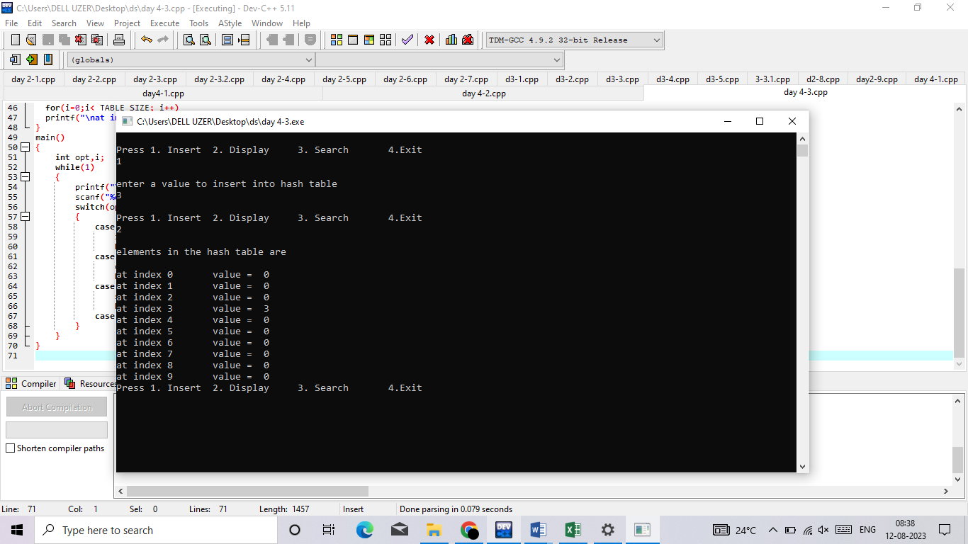

4. i)bubble sort

int main(){

int a[50], i,j,n,t;

printf("enter the No: of elements in the list:");

scanf("%d", &n);

printf("enter the elements:");

for(i=0; i<n; i++){

scanf ("%d", &a[i]);

}

printf("Before bubble sorting the elements are:");

for(i=0; i<n; i++)

printf("%d \t", a[i]);

for (i=0; i<n-1; i++){

for (j=i+1; j<n; j++){

if (a[i] > a[j]){

t = a[i];

a[i] = a[j];

a[j] = t;

}

}

}

printf ("\nafter bubble sorting the elements are:");

for (i=0; i<n; i++)

printf("%d\t", a[i]);

return 0;

}

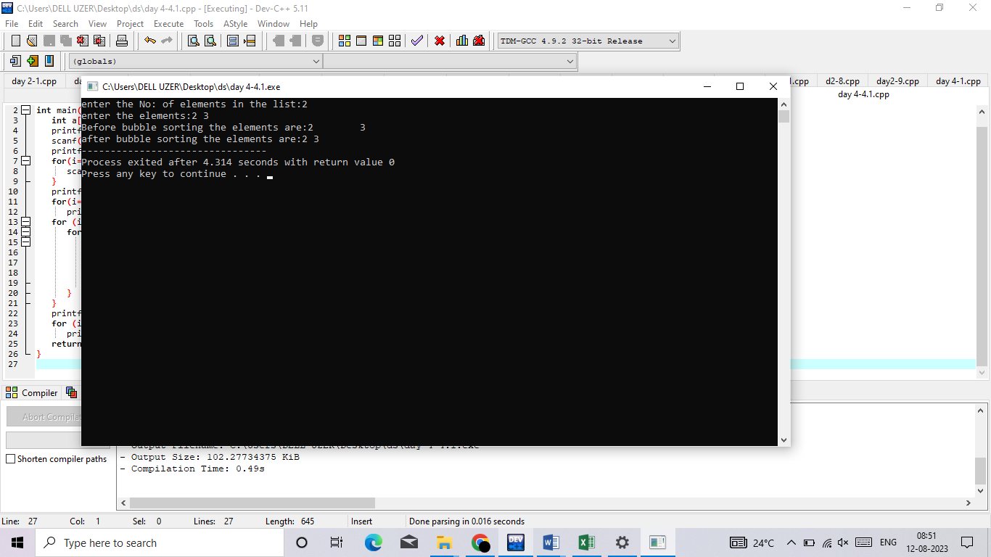

ii) selection sort

#include <stdio.h>

int main()

{

int array[100], n, c, d, position, t;

printf("Enter number of elements\n");

scanf("%d", &n);

printf("Enter %d integers\n", n);

for (c = 0; c < n; c++)

scanf("%d", &array[c]);

for (c = 0; c < (n - 1); c++) // finding minimum element (n-1) times

{

position = c;

for (d = c + 1; d < n; d++)

{

if (array[position] > array[d])

position = d;

}

if (position != c)

{

t = array[c];

array[c] = array[position];

array[position] = t;

}

}

printf("Sorted list in ascending order:\n");

for (c = 0; c < n; c++)

printf("%d\n", array[c]);

return 0;

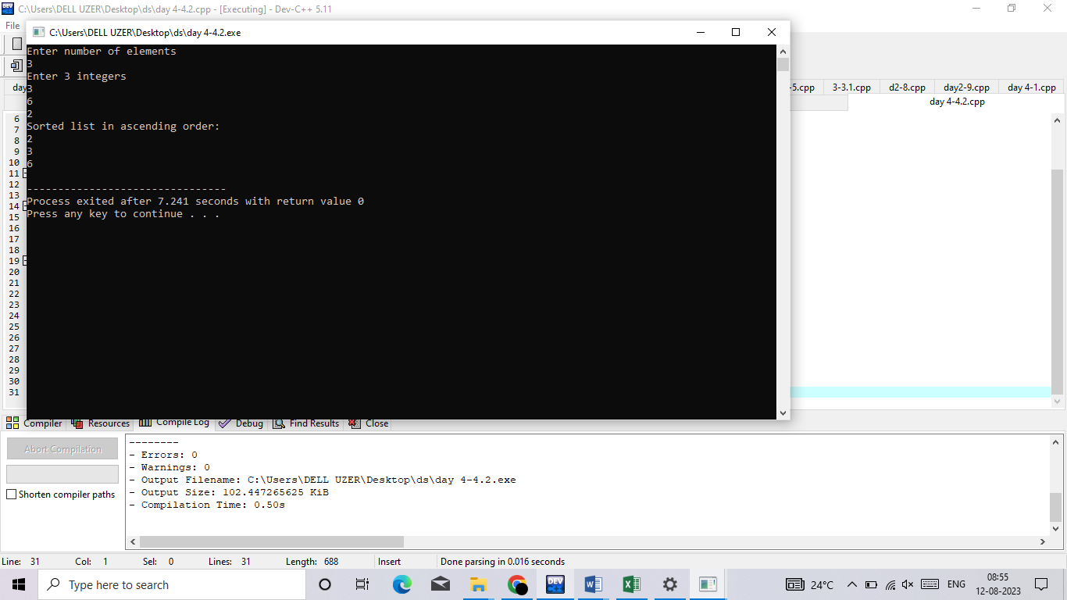}

iii) insertion sort

#include <math.h>

#include <stdio.h>

void insertionSort(int arr[], int n)

{

int i, key, j;

for (i = 1; i < n; i++)

{

key = arr[i];

j = i - 1;

while (j >= 0 && arr[j] > key)

{

arr[j + 1] = arr[j];

j = j - 1;

}

arr[j + 1] = key;

}

}

void printArray(int arr[], int n)

{

int i;

for (i = 0; i < n; i++)

printf("%d ", arr[i]);

printf("\n");

}

int main()

{

int arr[] = {12, 15, 11, 9, 2};

int n = sizeof(arr) / sizeof(arr[0]);

insertionSort(arr, n);

printArray(arr, n);

return 0;

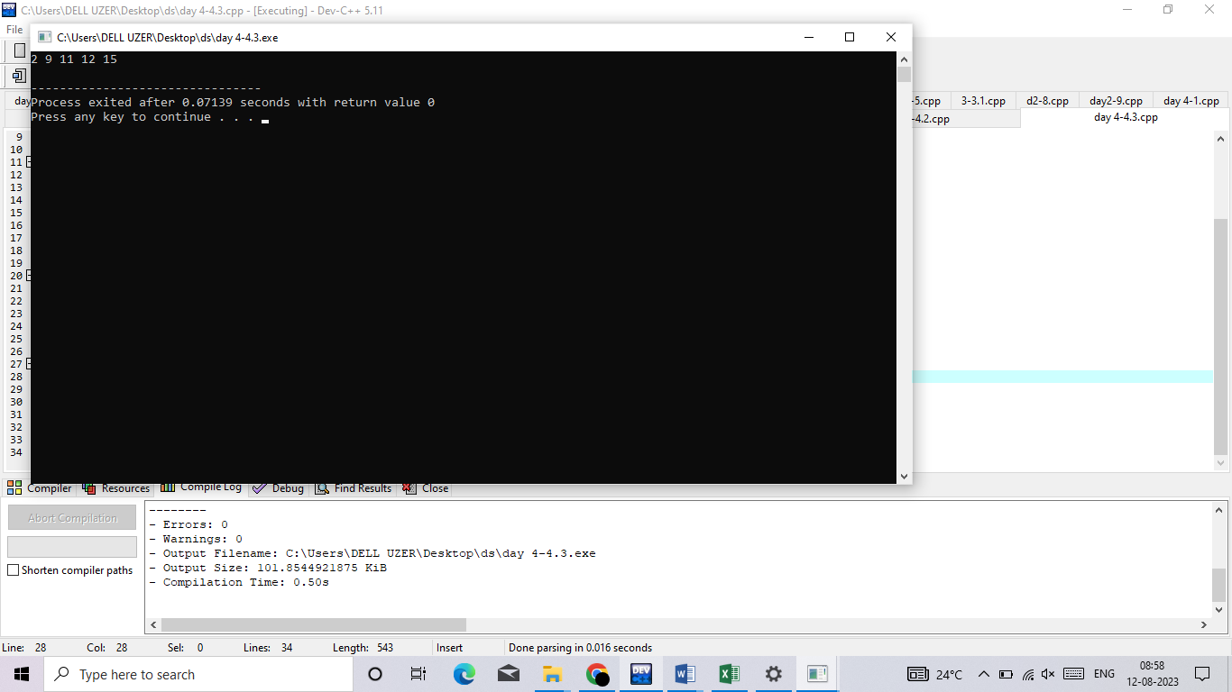}

# *4.quick sort :*

#include<stdio.h>

void quicksort(int number[25],int first,int last){

int i, j, pivot, temp;

if(first<last){

pivot=first;

i=first;

j=last;

while(i<j){

while(number[i]<=number[pivot]&&i<last)

i++;

while(number[j]>number[pivot])

j--;

if(i<j){

temp=number[i];

number[i]=number[j];

number[j]=temp;

}

}

temp=number[pivot];

number[pivot]=number[j];

number[j]=temp;

quicksort(number,first,j-1);

quicksort(number,j+1,last);

}

}

int main(){

int i, count, number[25];

printf("How many elements are u going to enter?: ");

scanf("%d",&count);

printf("Enter %d elements: ", count);

for(i=0;i<count;i++)

scanf("%d",&number[i]);

quicksort(number,0,count-1);

printf("Order of Sorted elements: ");

for(i=0;i<count;i++)

printf(" %d",number[i]);

return 0;

}

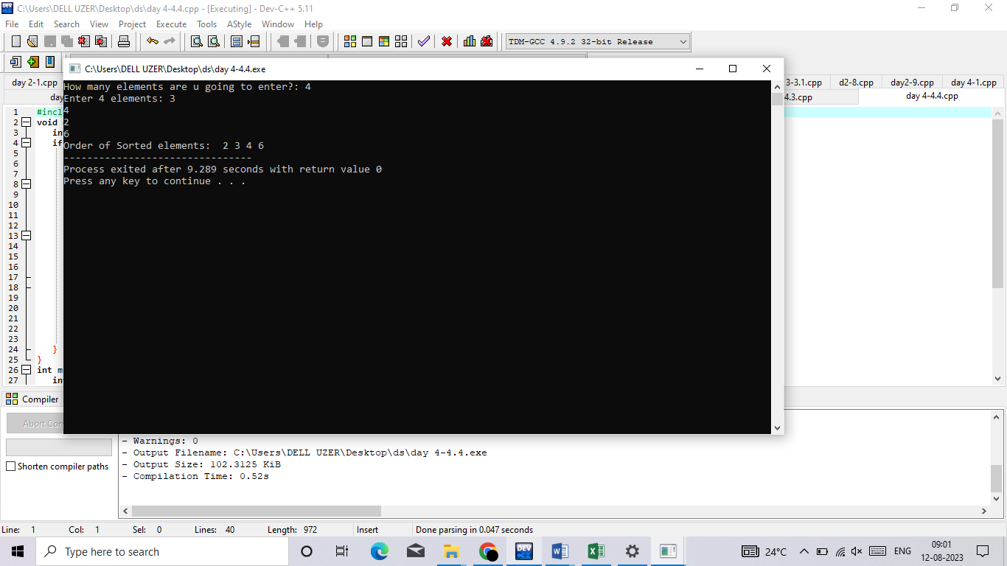

5) merge sort

#include <stdio.h>

#include <stdlib.h>

void merge(int arr[], int l, int m, int r)

{

int i, j, k;

int n1 = m - l + 1;

int n2 = r - m;

int L[n1], R[n2];

for (i = 0; i < n1; i++)

L[i] = arr[l + i];

for (j = 0; j < n2; j++)

R[j] = arr[m + 1 + j];

i = 0;

j = 0;

k = l;

while (i < n1 && j < n2) {

if (L[i] <= R[j]) {

arr[k] = L[i];

i++;

}

else {

arr[k] = R[j];

j++;

}

k++;

}

while (i < n1) {

arr[k] = L[i];

i++;

k++;

}

while (j < n2) {

arr[k] = R[j];

j++;

k++;

}

}

void mergeSort(int arr[], int l, int r)

{

if (l < r) {

int m = l + (r - l) / 2;

mergeSort(arr, l, m);

mergeSort(arr, m + 1, r);

merge(arr, l, m, r);

}

}

void printArray(int A[], int size)

{

int i;

for (i = 0; i < size; i++)

printf("%d ", A[i]);

printf("\n");

}

int main()

{

int arr[] = { 12, 11, 13, 5, 6, 7, 8, 9 };

int arr_size = sizeof(arr) / sizeof(arr[0]);

printf("Given array is \n");

printArray(arr, arr_size);

mergeSort(arr, 0, arr_size - 1);

printf("\nSorted array is \n");

printArray(arr, arr_size);

return 0;

}

